**Technical Summary: Gender Classification Under Challenging Conditions (COMSYS 2025 Hackathon - Task A)**

**Objective**

The project aims to build a robust gender classification system that operates effectively under challenging real-world conditions such as blur, noise, occlusion, and illumination changes.

**Approach**

* Layers layer2, layer3, layer4 are fine-tuned.
* Other layers are frozen to retain pre-learned visual features.
* Final classifier layers are:
  + Linear(2048 → 1024) → ReLU → Dropout
  + Linear(1024 → 512) → ReLU → Dropout
  + Linear(512 → 2) for binary classification

**Architecture Overview**

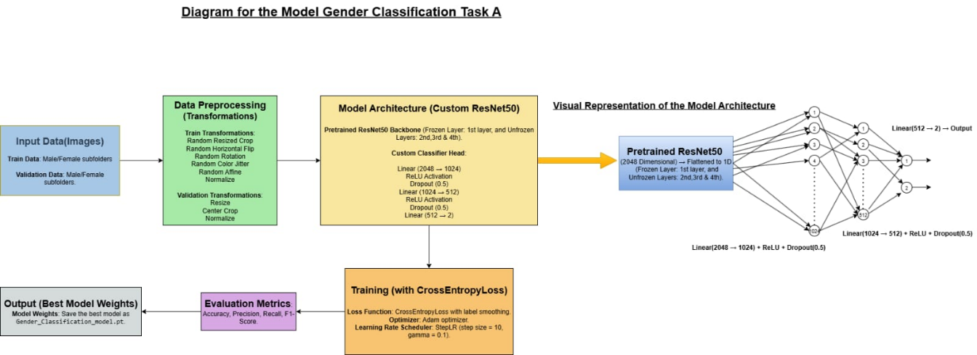

**Innovations**

The project pioneers a resilient gender classification system engineered to thrive in real-world scenarios—where images are blurred, noisy, partially occluded, or poorly lit—pushing the boundaries of computer vision beyond clean lab conditions into the unpredictable complexities of everyday environments.

**Conclusion**

The Insight Syndicate team's approach is to balance model accuracy and robustness under degraded conditions. With strong augmentation, attention-enhanced ResNet, and a carefully tuned training strategy, the model delivers promising results in gender classification for real-world, noisy inputs.